- \Operation\Upstream machine\Upstream machine
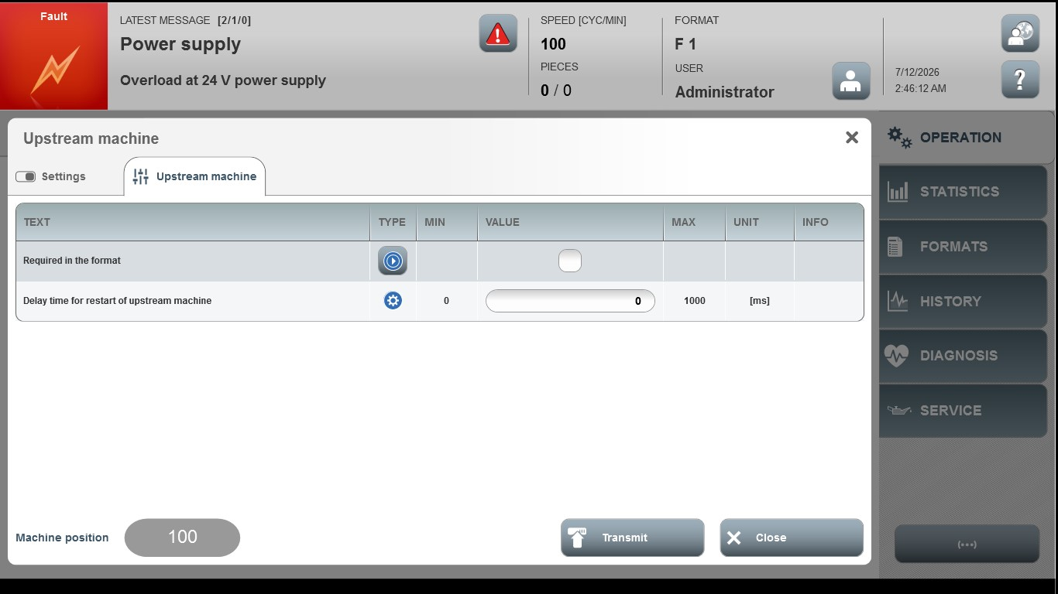

Acceptance criterion | Limits | Pass / Fail: Dev-No. | Date | Initials
Screen matches screenshot | N / A
Delay time for restart for upstream machine | 0 … 1000

